# How to launch application

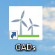double click to open (when you first launch the application, the default database is mydb)

# Creating and connecting to databases

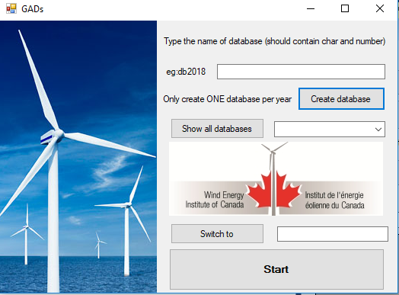

Option 2: choose the database and click “switch to” to change the database, and click start

Option 3: just click start, the connected database is the last one

Option 1: type the name of database you want to create, and then click the “create database” (create only one database per year). then click start

Click to see all the database

# Selecting GADS data files to database and calculation

## Files following 2016 or later standard

1. Click “choose CSVs” on front panel
2. Navigate to folder with GADS Data for one wind farm
3. Type key word (eg: outage) in search box
4. Select only 12 outages files/ Select only 12 outages files/ Select only one (January) file for SubGroup
5. Click “Open”
6. Click “import from CSVs”
7. Choose “After 2016” option and click “Create 3 tables” (you may need to change the name: make sure you change the name from WEICAN to WEICan in farm name textbox)
8. Click “export to SQL” (you may need to change the name: make sure the table name textbox is ’SNEEC_Outages’ instead of ‘SNEEC_Outage’)

Note: use viewgrid to fix the data. Common mistakes: TechnoCenter/SNEEC: The type of StatusEffDate is wrong (Solution: delete the zero)

Kruger_KEMONT group file: The type of Longitude, Latitude are wrong. (Solution: change to “12.34” format) SCADA_Model: too long. Please change to right type(string) or less than 10 characters

1. Close the current panel and click “start” again
2. Do the c,d,e,f,h,i another twice for other types of files (outages/performance/SubGroup)
3. Click “calculation”

What happens if you select less than 12 files for performance or outages? No error prompt, but wrong

## Files following GADS standard older than 2016

1. Click “choose CSVs” on front panel
2. Navigate to folder with GADS Data for one wind farm
3. Type key word (eg: outage) in search box
4. Select only 12 Component (may also name outage) files/ Select only 12 performance files/ Select only one (January) file for SubGroup/ Select only one (January) file for Group
5. Click “Open”
6. Click “import from CSVs”
7. Choose “Before 2016” option and click “Create 4 tables” (you may need to change the name: make sure you change the name from WEICAN to WEICan in farm name textbox)
8. Click “export to SQL” (make sure change the table name box: Outages🡪Component, SubGroup🡪Sub_Groups, Performance🡪 Plant_Performance, Group🡪Groups)

Note: use viewgrid to fix the data. Common mistakes: TechnoCenter/SNEEC: The type of StatusEffDate is wrong (Solution: delete the zero)

Kruger_KEMONT group file: The type of Longitude, Latitude are wrong. (Solution: change to “12.34” format) SCADA_Model: too long. Please change to right type(string) or less than 10 characters

1. Close the current panel and click “start” again
2. Do the 3,4,5,6,8,9 for another 3 times for other types of files (Component, Sub_Groups, Plant_Performance, Groups)
3. Click “tables conversion: old to new”
4. Click “calculation”

What happens if you select less than 12 files for performance or outages? No error prompt, but wrong

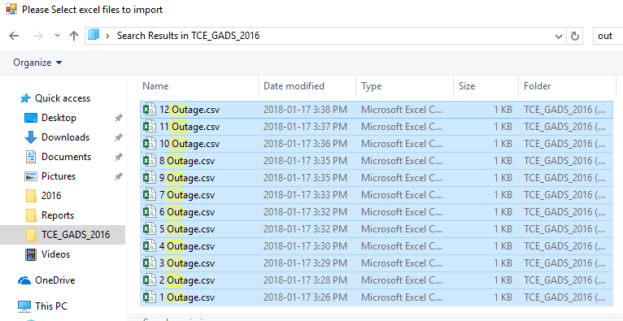

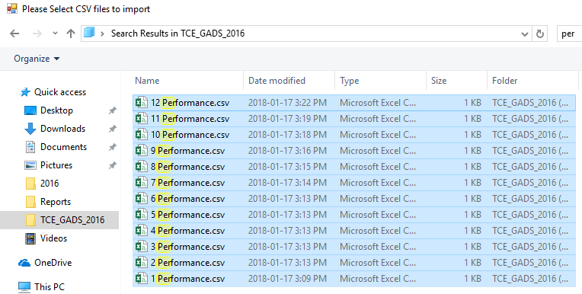

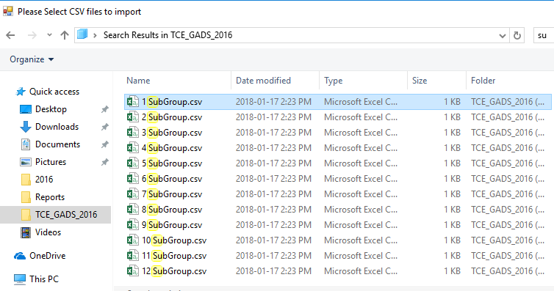

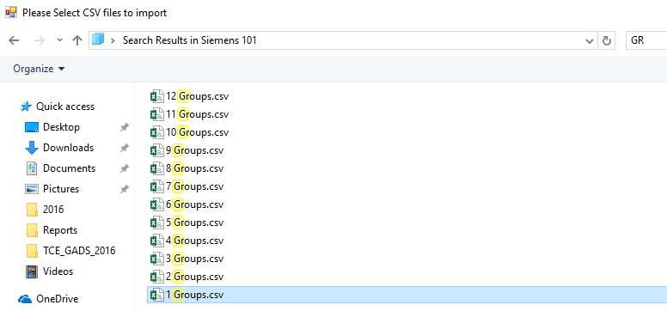

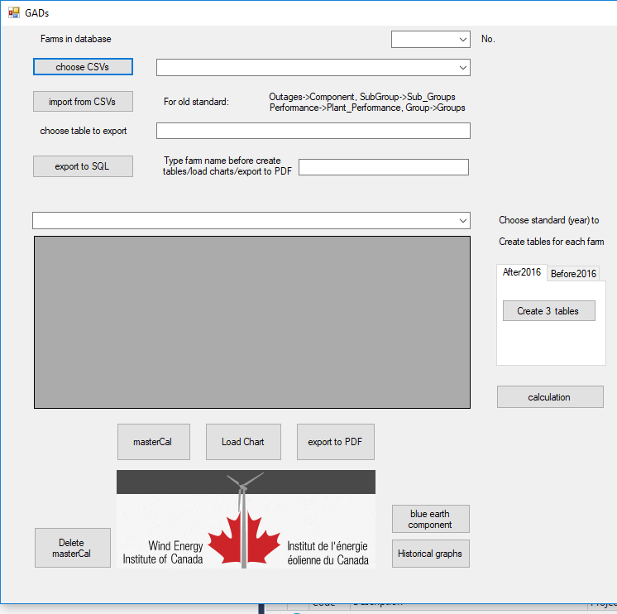

Delete the master calculation if you click “masterCal” mistakenly.

Function unavailable, need to add historical tables to database

Replace “import from CSVs”, when it comes to blue earth component.

Note: For one farm: normally you do step1, 2, 3, 4 for one time, and then step1,2,4 for twice, and then step5. If it is old format, make sure you click ”tables conversion” After you export all (4 types) files to database(before step5).

This window shows the data and you can change it to meet the requirements

Choose the table you want to display

Farm name (used a lot)

Name of table you want to export to

Files you choose

If 5 types of CSV, choose “Before 2016”, 3 types choose “After 2016”

Number of farms

List of farms

Click “Farms in database” to show the current database and farms inside



**Step8:** Generate a debugging report and a final report for that farm

**Step7**: click it for the farm in “Farm name” textbox

**Step6:** only click once for all the farms

**Step5:** Click “calculation” After imported all the files for one farm

**Step4**

**Step3:** click only one time for each farm

**Step2**

**Step1**: select 12 (Jan to Dec) files (Outages/Performance) Or one (Jan) file (Group/SubGroup) at one time

# Create reports

1. After you import all the farms and do the calculations, click “masterCal” (only do it once, the function is for all farms)
2. Click “Load Chart” to generate charts for farm in farm name textbox content (before clicking “Export to PDF”).
3. Click “export to PDF” to generate the debugging and final report

Default path to store the PDF: W:\Projects\5032 - GADS\Reports

# Maintaining software

Location of database: open “Microsoft SQL Server Management Studio 17” and you can find them

c:\Program Files\Microsoft SQL Server\MSSQL14.MSSQLSERVER\MSSQL\

Software source code: C:\Users\CWFB\source\repos\WindowsFormsApp1,

W:\Projects\5032_GADS_Source_Code\

open the source code using Visual Studio 2017

Additional software required to edit / maintain software (C#(.Net), visual studio 2017, SQL Server 2017)

Download links: <https://visualstudio.microsoft.com/downloads/>

<https://www.microsoft.com/en-ca/sql-server/sql-server-downloads>

Software structure:

Click “Create database” to define a new db, connect to it and copy the sys-com table to db

Loop through every cells (ExportDataTableToPdf1) Copy all the tables and charts (ExportDataTableToPdf1) to the datasets and print them to two paths

20 queries to create GADs description. Define 10 charts and bind with the tables

Store the path of select files, parser (GetDataTableFromCSVFile(source)) to go through each line of each file, and copy them to a dataset in database

After import all farms, pass queries to create 6 summary views based on every farm

Pass the queries to create 3 or 4 tables for each farm according to standard

Make connections and loop to copy all the data to the table in db

Pass all the 14 queries to db and generate the results (views)